Practical: -4

Aim: - ER Diagram Relation Schema

1.Create Database.

SQL> CREATE TABLE Employee1 (ID NUMBER PRIMARY KEY, name VARCHAR2(100), position VARCHAR2(50), pay_rate NUMBER (10,2), pay_type VARCHAR2(20), supervisor NUMBER, FOREIGN KEY (supervisor) REFERENCES Employee1(ID));

SQL> desc Employee1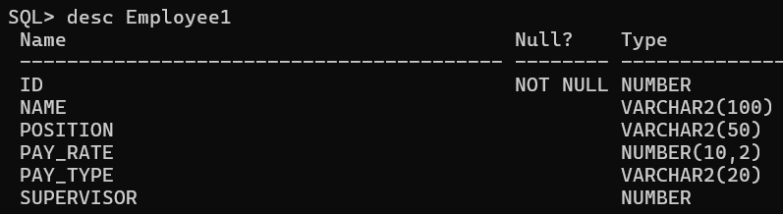

SQL> CREATE TABLE Factory (fac_ID NUMBER PRIMARY KEY, fac_name VARCHAR2(100),

city VARCHAR2(100), throughput NUMBER);

SQL> desc Factory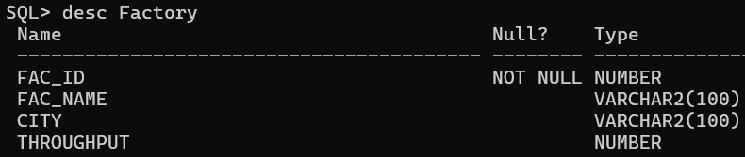

SQL> CREATE TABLE Assembly_Line (ID NUMBER PRIMARY KEY, factory_id NUMBER, line_number NUMBER, throughput NUMBER, FOREIGN KEY (factory_id) REFERENCES Factory(fac_ID));

SQL> desc Assembly_Line

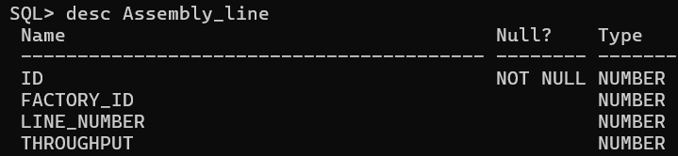

SQL> CREATE TABLE Part (part_number NUMBER PRIMARY KEY, description VARCHAR2(255));

SQL> desc part

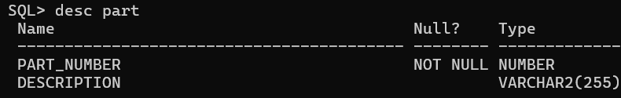

SQL> CREATE TABLE Vendor (ID NUMBER PRIMARY KEY,

name VARCHAR2(100),

email VARCHAR2(100),

phone VARCHAR2(20));

SQL> desc Vendor

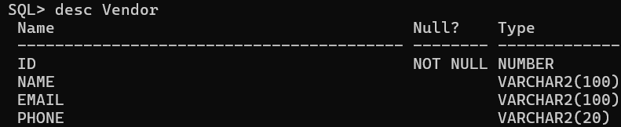

CREATE TABLE Part_Vendor (

part_number NUMBER,

vendor_id NUMBER,

price NUMBER (10,2),

PRIMARY KEY (part_number, vendor_id),

FOREIGN KEY (part_number) REFERENCES Part(part_number),

FOREIGN KEY (vendor_id) REFERENCES Vendor (ID));

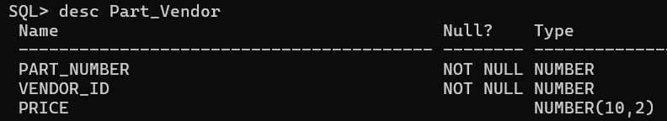SQL> desc Part_Vendor

CREATE TABLE Works_At (

employee_id NUMBER,

factory_id NUMBER,

PRIMARY KEY (employee_id, factory_id),

FOREIGN KEY (employee_id) REFERENCES Employee1(ID),

FOREIGN KEY (factory_id) REFERENCES Factory(fac_ID));

SQL> desc Works_At

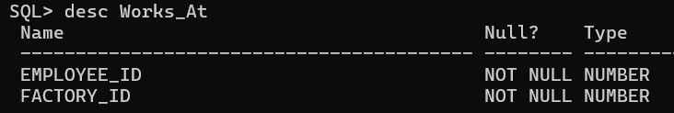

CREATE TABLE Manages (

manager_id NUMBER,

factory_id NUMBER,

PRIMARY KEY (manager_id, factory_id),

FOREIGN KEY (manager_id) REFERENCES Employee1(ID),

FOREIGN KEY (factory_id) REFERENCES Factory(fac_ID));

SQL> desc Manages

